Advanced Visuals in Tableau Assignment Question
_________________________________________________________________________________

Question 1: Create a Heatmap to analyze Treatment Cost by Department and Region.

Answer

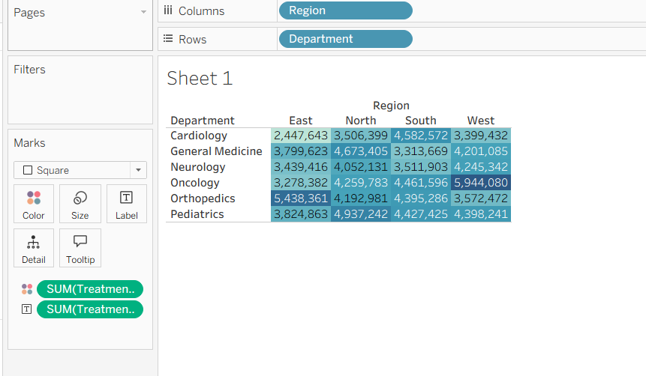

Question 2: Create a Highlight Table showing Satisfaction Score by Department.

Answer

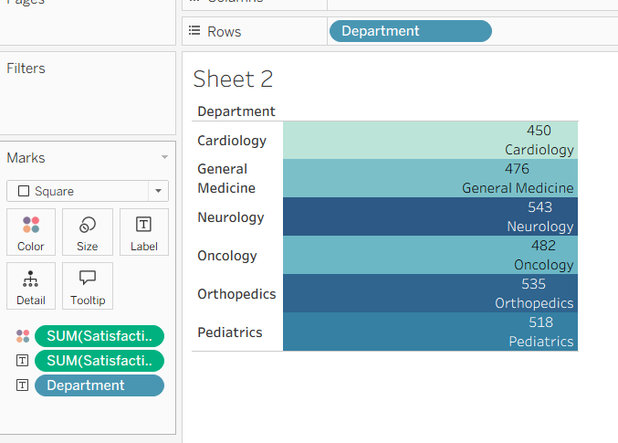

Question 3: Create a Bump Chart to show ranking of Departments based on Treatment Cost over months.

Answer

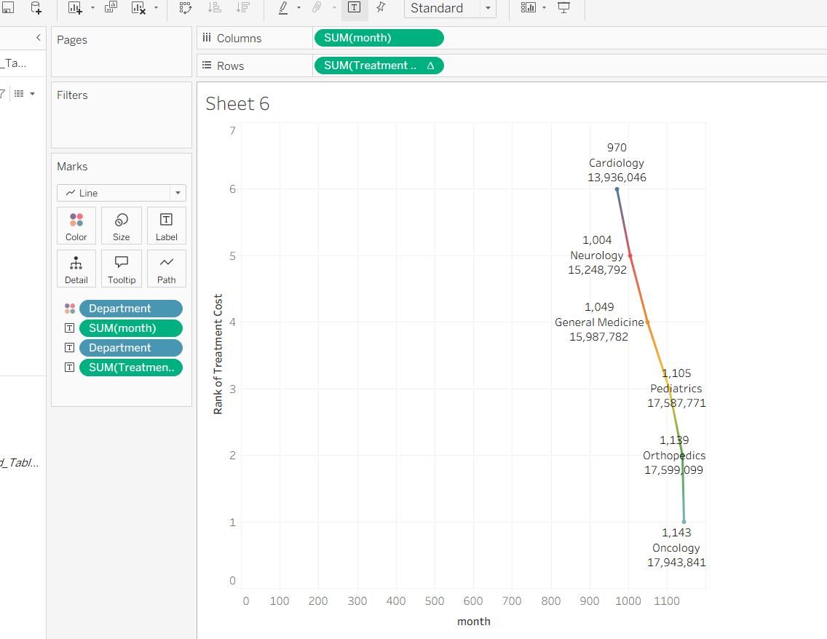

Question 4: Create a Butterfly Chart comparing Male vs Female patient count by Department.

Answer

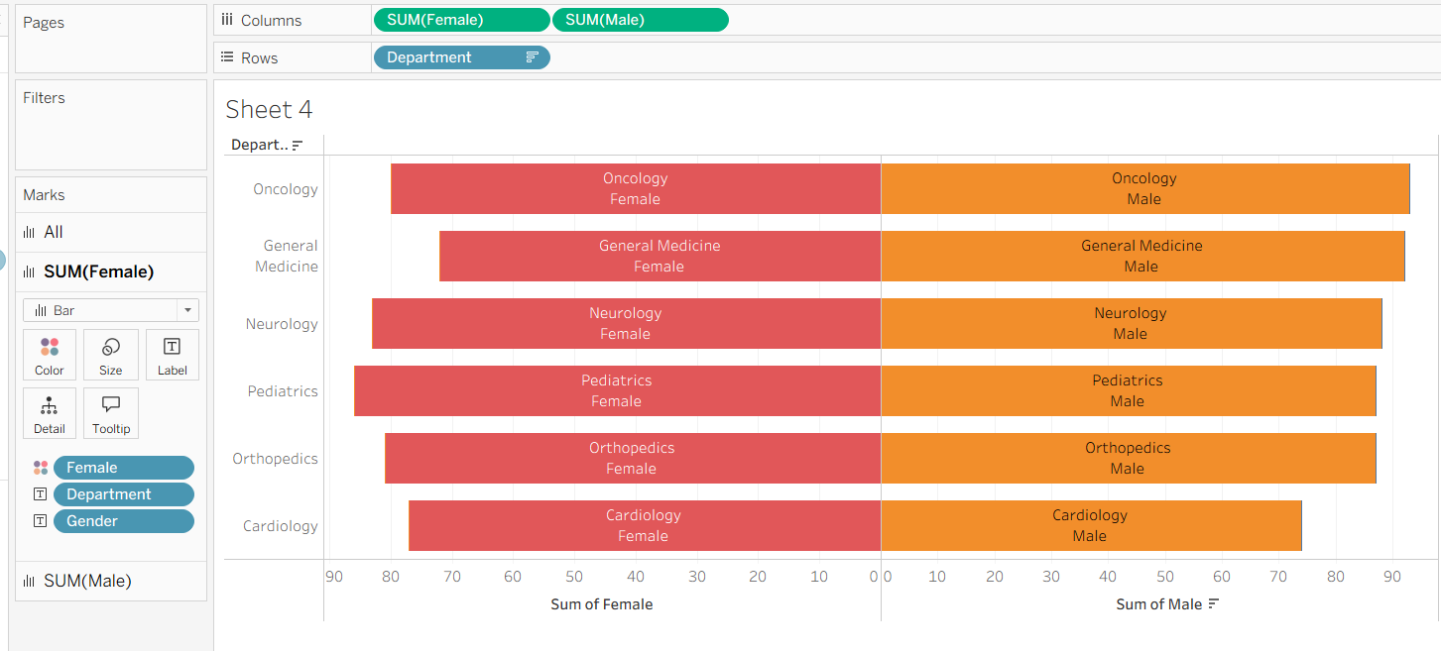

Question 5 : Create a Dual Axis Chart to compare Average Age and Treatment Cost by Department.

Answer
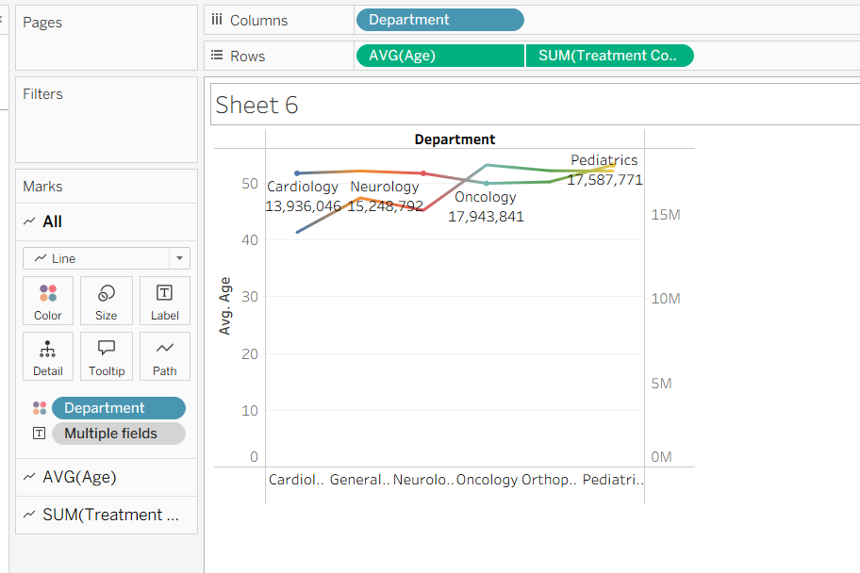

Question 6: Create a Sunburst Chart showing Department → Diagnosis hierarchy by Treatment Cost.

Answer

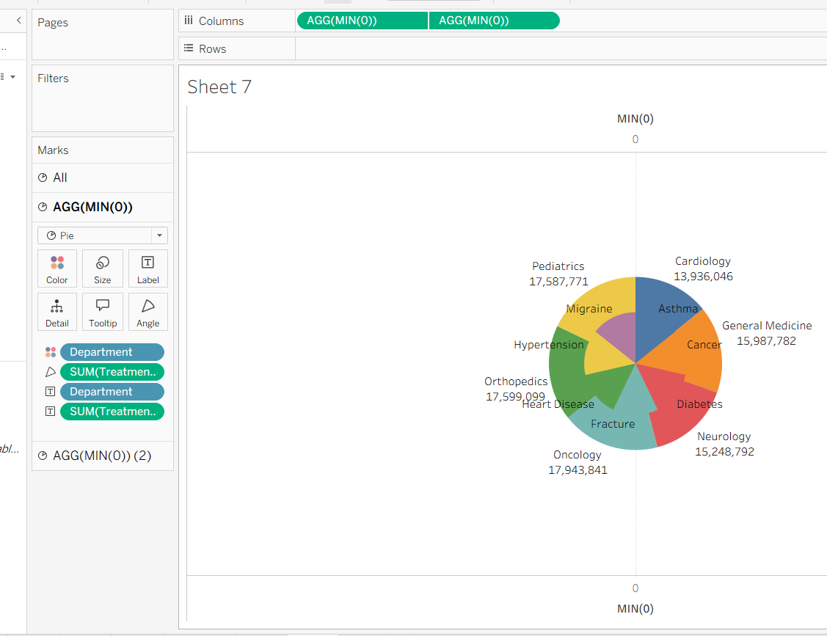

Question 7: Create a Dual Axis Chart comparing Treatment Cost and Satisfaction Score by Department.

Answer

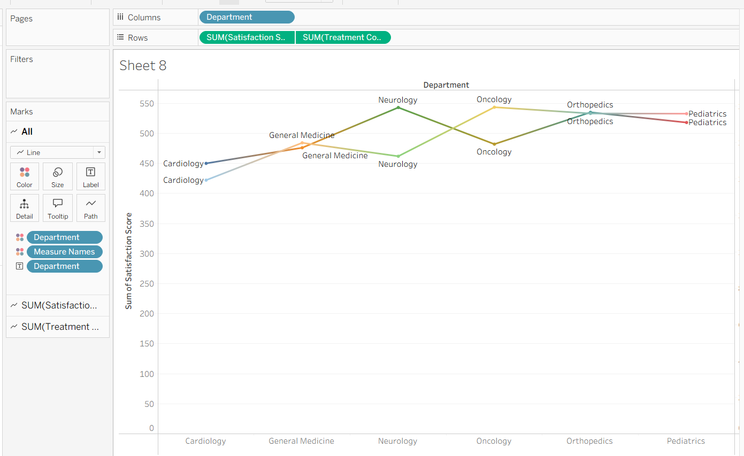

Question 8: Create a Dashboard combining:
- Heatmap
- Dual Axis Chart
- Sunburst Chart
- Butterfly Chart
Answer
